Blinn-Phong Model

📘 Definition
# Source: AI Source: Provided by: [Data Path: Persons Table -> ID Column: 1, Name_En Column: Motasem Essam] -> From: [ChatGPT] on [5/2/2026]
The Blinn-Phong Model is a lighting model in computer graphics used to create realistic lighting and shiny highlights on 3D objects. It is an improved version of the Phong model and is more efficient for modern graphics.

💡 How Blinn-Phong Model works
# Source: AI Source: Provided by: [Data Path: Persons Table -> ID Column: 1, Name_En Column: Motasem Essam] -> From: [ChatGPT] on [5/2/2026]
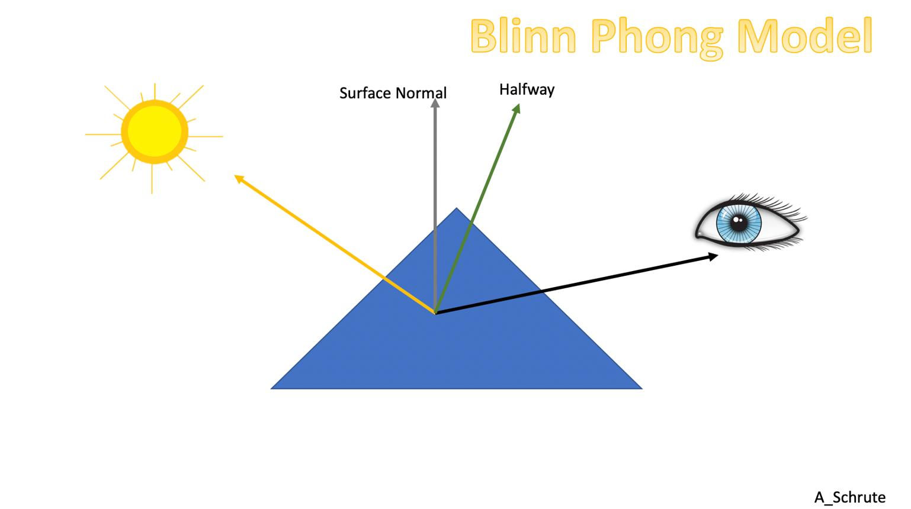
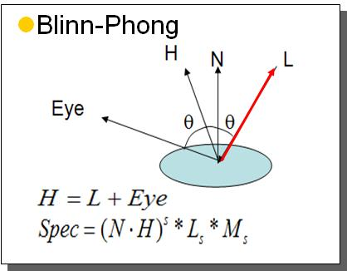
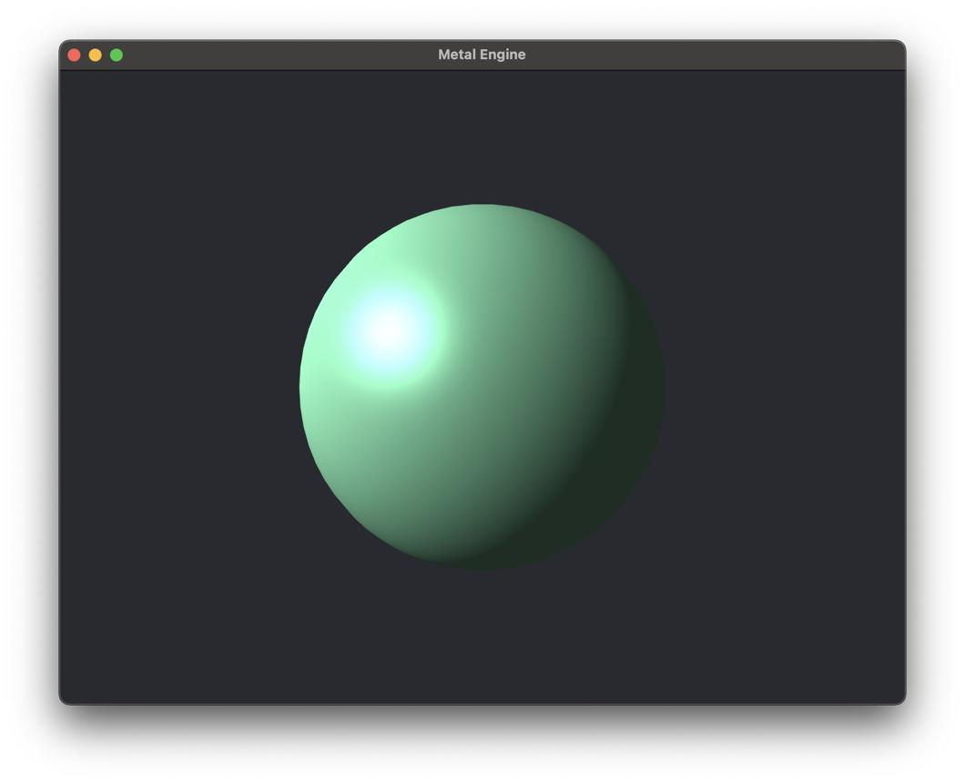
It combines three main components:
- 🌫️ Ambient light → soft general lighting
- 💡 Diffuse light → light spread on rough surfaces
- ✨ Specular light → shiny highlight using a half-vector method
👉 The key idea: it calculates highlights in a faster and smoother way than the original Phong model.

🧠 Simple example
# Source: AI Source: Provided by: [Data Path: Persons Table -> ID Column: 1, Name_En Column: Motasem Essam] -> From: [ChatGPT] on [5/2/2026]
Think of a shiny ball under a light:
- The ball is softly lit overall (ambient + diffuse)
- A bright shiny spot appears where light reflects (specular highlight)
- The highlight looks smoother and more stable than in Phong shading

🎮 Where Blinn-Phong Model is used
# Source: AI Source: Provided by: [Data Path: Persons Table -> ID Column: 1, Name_En Column: Motasem Essam] -> From: [ChatGPT] on [5/2/2026]
- 🎮 Real-time video games
- 🎬 3D animation and CGI
- 🧑‍💻 Game engines (like Unity, Unreal Engine older pipelines)
- 🕶️ VR and real-time rendering systems

⚙️ Key features
# Source: AI Source: Provided by: [Data Path: Persons Table -> ID Column: 1, Name_En Column: Motasem Essam] -> From: [ChatGPT] on [5/2/2026]
- ✨ Produces smooth and realistic highlights
- ⚡ Faster than the original Phong model
- 🎯 Uses a half-vector for efficient specular calculation
- 🌗 Works well for real-time graphics

🚀 In short:
# Source: AI Source: Provided by: [Data Path: Persons Table -> ID Column: 1, Name_En Column: Motasem Essam] -> From: [ChatGPT] on [5/2/2026]
Blinn-Phong Model = a lighting model that creates realistic shiny effects using ambient, diffuse, and improved specular lighting (faster than Phong).

